SAMPLE Fitness Center Provisions

Consider including a fitness center membership covenant or agreement for adults:

ASSUMPTION OF RISK
I understand that participation in an exercise program involves the risk of injury, illness, or death. I acknowledge these risks and affirm that I am willing to assume responsibility should injury, illness, or death result. I further understand that before participating in an exercise program I should consult a physician for advice.

RELEASE
In consideration for my permissive use of <CHURCH NAME> facilities, I agree on behalf of myself, my heirs, executors, and assigns to fully and forever release and discharge <CHURCH NAME>, its officers, directors, volunteers, and employees from any and all liability, claims, demands, damages, actions or causes of action that arise or that are in any way related to my use of <CHURCH NAME> facilities to the fullest extent permitted by law.

HOLD HARMLESS
I hereby agree to indemnify and save and hold harmless <CHURCH NAME> , its officers, directors, volunteers and employees from any loss, liability, damage or cost they may incur due to my participation in, or use of, <CHURCH NAME> facilities to the fullest extent permitted by law.

MEDICAL COSTS/INSURANCE
I understand that <CHURCH NAME> does not provide medical insurance coverage for me for any injury or illness arising from my use of the facilities. I certify that I have, or will obtain health insurance coverage for myself and agree that I will submit any costs for treatment for any injury or illness arising from my use of the facilities through my own health insurance, or will otherwise be financially responsible for such costs.

EMERGENCY MEDICAL TREATMENT
I hereby give my consent for <CHURCH NAME> to secure emergency medical treatment for myself in the event that I am unable to give such consent due to injury or illness. It is understood that <CHURCH NAME> will provide no medical insurance for such treatment, and that the cost thereof will be at my expense.

Full Name (Printed)

Signature Date
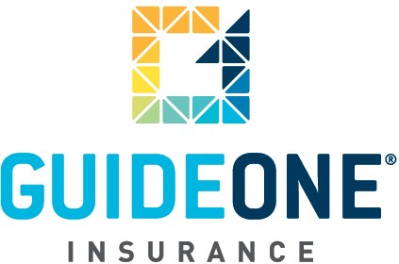

(05.15.2012)
© 2012 GuideOne Center for Risk Management, LLC. All rights reserved.
This material is for information only and is not intended to provide legal or professional advice.
You are encouraged to consult with your own attorney or other expert consultants for a professional opinion specific to your situation.

